Coate, Kevin

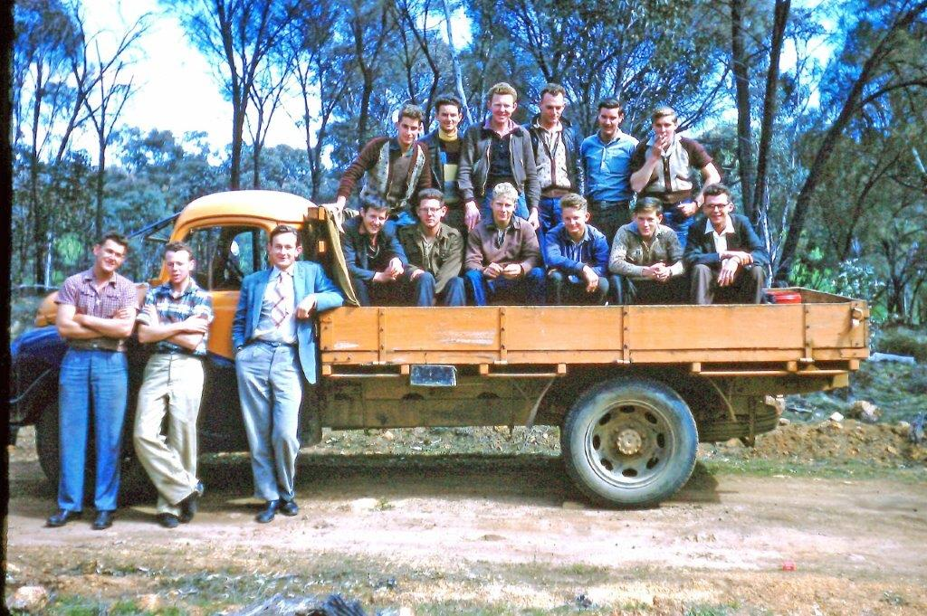1958 trainees

(Kevin Coate provided the following notes)
I joined the Forests Department in December 1951 as a 15 year old junior. Although under the required age I was accepted into the 1952 intake of Trainee's/Cadets in August 1952 - the first intake since WW2. Other Trainees were Gordon Styles, Brian Baker, Jim Raper, Kevin Barrett, Stan Williams, Lyle Johnson, Archie Hancock, Jim Percival and two others whose name eludes me who didn't stay long. In March 1955 although still under age, I was appointed a Forest Guard.
In September-October 1958 I attended a school for the second intake of Trainees and some Forest Guards at Dwellingup, and assisted Frank Podger with lectures and field trips. The above photo is of that group on a field trip to Dryandra. Standing beside the truck is Kevin Coate, Jim Percival and Frank Podger.

Other notes
(Tom Wood is on the truck ?)
From Kimberley Society website: At the meeting of 2 June 1999, well-known naturalist and tour leader Kevin Coate spoke on 'The early 1960s era in the Kimberley constructing the Gibb River and other beef roads'. Kevin was president of the WA Naturalists' Club. Kevin used slides showing the condition of the roads when he became involved in road construction in the Kimberley in 1961-1963.

From Wiki Australia website: Coates Wildlife Tours
Tours offering spectacular and diverse natural history – flora, fauna, Aboriginal art, paintings and culture.
Since 1980, when naturalist, Kevin Coate founded Coates Wildlife Tours and pioneered the inception of nature-based tours in Western Australia, we have offered tours that let you experience nature in small groups and allow plenty of time and flexibility to pursue individual interests.
Great Destinations:
The Kimberley and Pilbara regions in the north, the Kennedy Ranges and Mt Augustus in the mid west and various areas through the south of Western Australia.

